**Lab 2: ADOBE PREMIERE PRO WITH VIDEO TRIMING**

**Introduction**

Adobe Premiere Pro is a leading video editing software widely used in the film, television, and web video industries. It offers a robust set of tools for cutting, trimming, and arranging video and audio clips, as well as advanced features like multi-camera editing, keyframing, and dynamic trimming. The software includes a variety of effects, transitions, and audio tools, along with professional color grading capabilities through the Lumetri Color panel. Seamlessly integrated with Adobe Creative Cloud, Premiere Pro allows for smooth collaboration and workflow, making it an essential tool for both novice and professional video editors.

The primary purpose of this lab is to familiarize oneself with the basic functionalities of Adobe Premiere Pro. This includes understanding its tools and interfaces, importing and organizing media files in the project panel, and using the timeline and sequence for trimming, cutting, and working with multiple tracks. Additionally, audio editing and mixing, applying video effects and transitions, adding subtitles, and vector marking will be covered. By gaining a foundational knowledge of these core aspects, better equipment for utilizing Adobe Premiere Pro for various video editing projects will be achieved.

**Objectives**

The main objectives of this lab are:

1. Introduction to Adobe Premiere Pro: Installing Adobe Premiere Pro and understanding its basic setup.
2. Getting Familiar with the Workspace: Understanding the toolbar, project panel, timeline, and program/source monitors.
3. Importing Media Files: Importing and organizing media in the project panel.
4. Using the Timeline and Sequence: Trimming and cutting clips, working with multiple tracks, and basic audio editing and mixing.
5. Applying Video Effects: Using transition effects and text masking.
6. Exporting the Project: Exporting the completed project in various formats for different platforms.

**1. Introduction to Adobe Premier Pro**

1. Setting up Adobe Premier Pro

* Visit the Adobe website and download the latest version of Adobe Premier Pro
* Run the installer and follow the on-screen instructions to complete the installation.
* Launch Adobe Premier Pro and sign in with your Adobe ID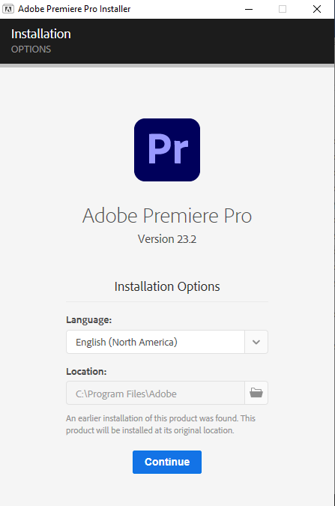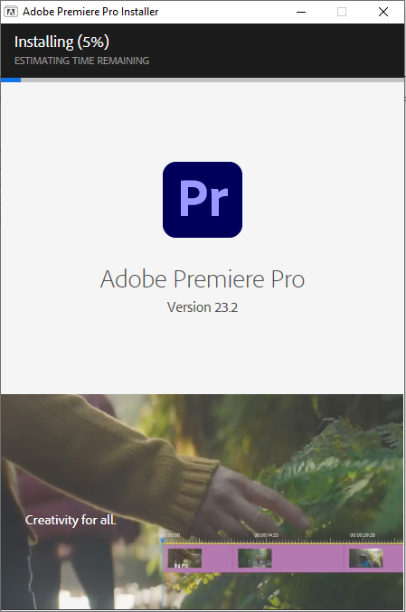

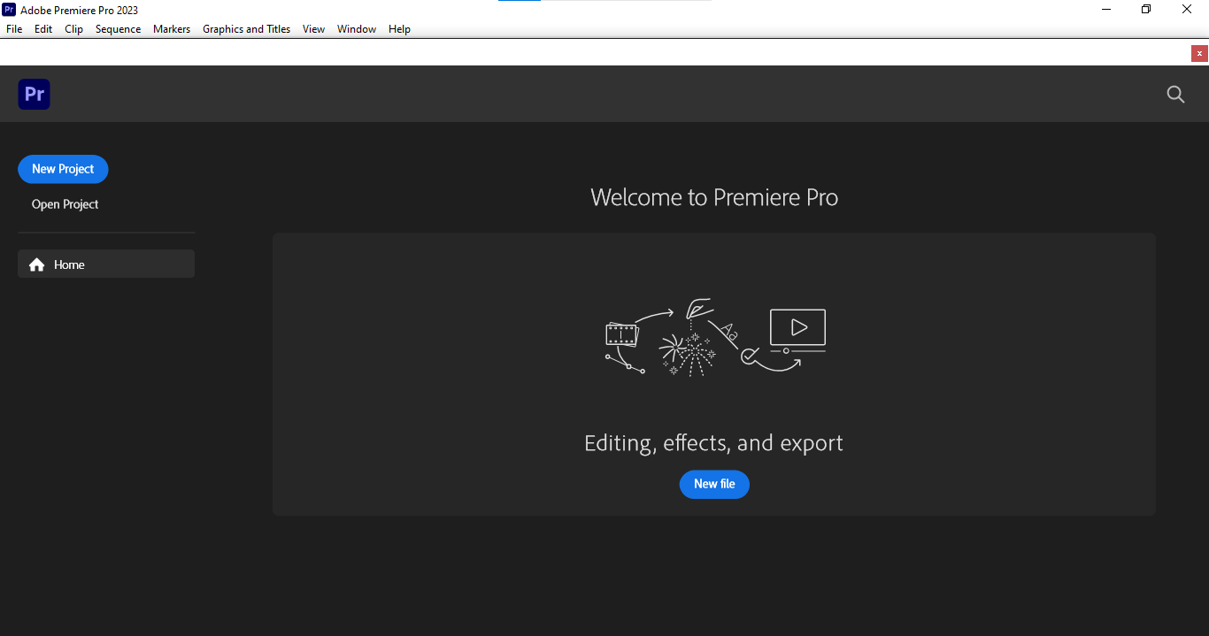

1. **Getting familiar with the workspace**

* Creating new project

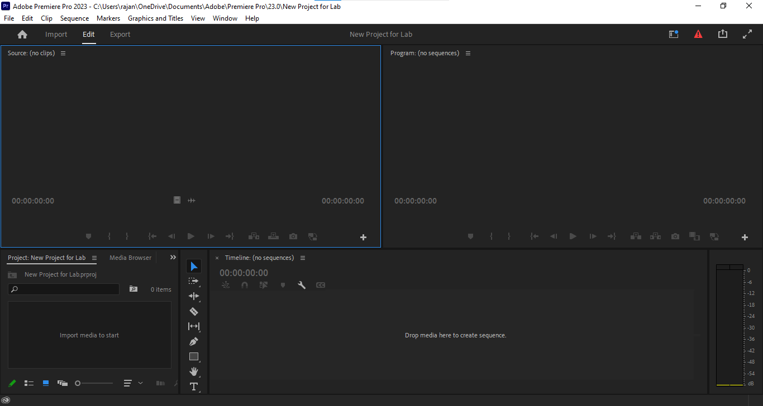

* Understanding the toolbar, project panel, timeline, and program/source monitors
  1. Toolbar:

Location: The toolbar is typically located on the left side of the interface, between the Project Panel and the Timeline.

* + - Tools Available: Selection Tool (V), Razor Tool (C), Pen Tool (P), Hand Tool(H), and Zoom Tool (Z), among others.
  1. Project Panel

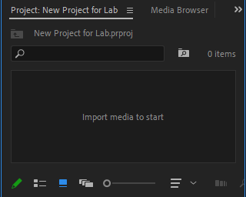

* Location: This panel is usually found in the lower left corner of the interface.
* Functionality: It is where you import, organize, and access all your media files, sequences, and other project assets. You can create bins (folders) here to organize your files.
  1. Timeline

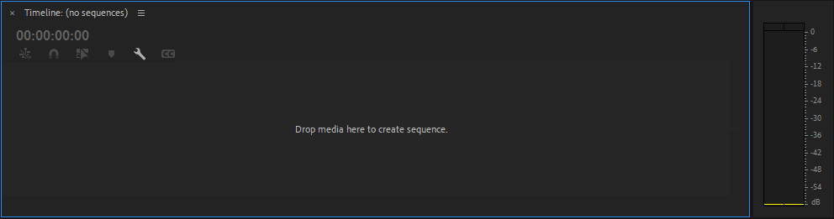

* Location: The Timeline is centrally located at the bottom of the interface.
* Functionality: This is where you assemble and edit your video and audio clips. You can add, trim, cut, and arrange your clips on multiple tracks.
  1. Program Monitor

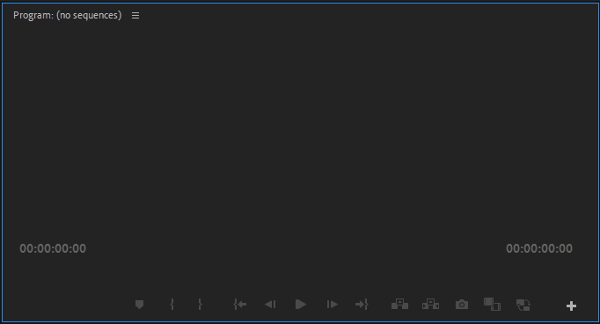

* Location: The Program Monitor is located in the top center of the interface.
* Functionality: It displays the sequence currently being edited in the Timeline. It allows you to preview your work as you edit.
  1. Source Monitor

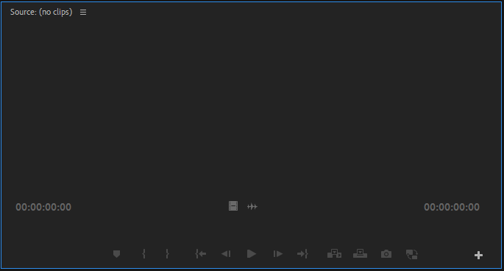

* Location: The Source Monitor is located in the top left corner of the interface, adjacent to the Project Panel.
* Functionality: This monitor is used to preview and trim raw clips before adding them to the Timeline. It helps you select the in and out points of your clips.

**3. Importing Media Files**

* Click "File" > "Import" or drag and drop media files into the project panel.

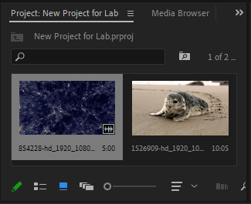

* 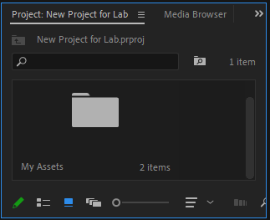Create bins (folders) to organize your assets. Right-click in the project panel and select "New Bin".
* Name and categorize your bins to keep your project organized.

**4. Using the Timeline and Sequence**

1. Trimming and Cutting Clips
   * Trimming Clips:

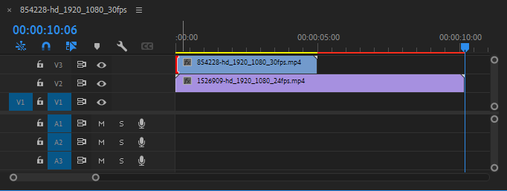

* + - Drag a video clip from the Project Panel (bottom left) to the Timeline.
    - Use the Selection Tool (V) to select the clip.
    - To trim the beginning or end, hover over the edge of the clip until you see a red bracket. Drag the edge inward to shorten the clip.
  + Cutting Clips:

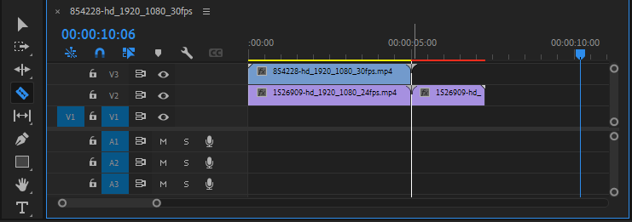

* Drag a video clip from the Project Panel to the Timeline.
* Select the Razor Tool (C) from the Toolbar (left side of the interface).
* Click on the clip at the point where you want to make a cut. The clip will be divided into two separate segments.

1. Working with Multiple Tracks

* Adding and Managing Tracks:

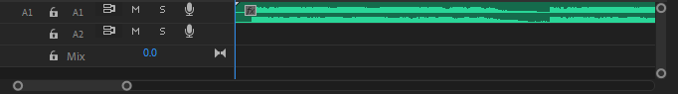

* Drag additional video or audio clips from the Project Panel to the Timeline, placing them on different tracks.
* To add a new track, right-click in the empty area of the track header on the left side of the Timeline and choose "Add Track" or "Add Audio Track".
* Use the Track Selection Tool (A) to move clips on different tracks. This tool is located in the Toolbar.
* Synchronizing and Layering Clips:
* Layer video clips on different tracks to create overlays, picture-in-picture effects, or composite shots.
* Synchronize audio and video by dragging and aligning them on the timeline. Use the snap feature (enabled by default) to make precise alignments easier.

1. Basic Audio Editing and Mixing

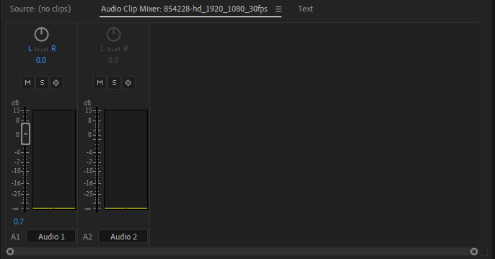

* Adjusting Audio Levels:
* Select an audio clip in the Timeline.
* Drag the horizontal volume line up or down to increase or decrease the volume.
* For more precise adjustments, go to the Audio Clip Mixer panel (Window > Audio Clip Mixer). Adjust the volume sliders for each track.
* Adding Audio Effects:

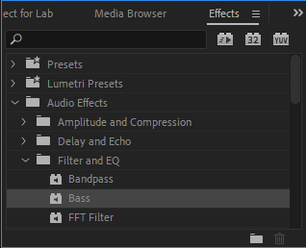

* Open the Effects panel and search for the desired audio effect (e.g., "Reverb" or "DeNoise").
* Drag the effect from the Effects panel to the audio clip in the Timeline.
* Adjust the effect parameters in the Effect Controls panel (top left) to achieve the desired sound.

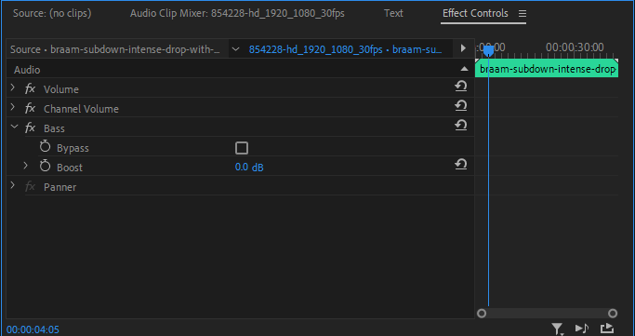

**5. Applying Video Effects**

1. Using transition effects

* Open the Effects panel and search for transitions like "Cross Dissolve".
* Drag the transition effect to the cut between two clips in the timeline.
* Adjust the duration and alignment of the transition by dragging its edges.

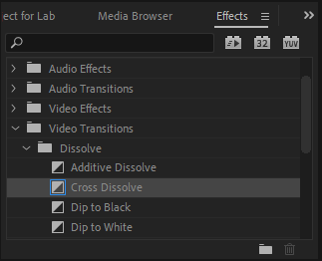

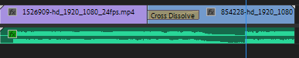

1. Text masking

* Go to the Essential Graphics panel (Window > Essential Graphics).
* Click on "New Layer" > "Rectangle".
* Adjust the size and position of the rectangle to cover the entire frame or the desired area.
* Place this rectangle layer on the timeline above the video clip (V2 track).
* Select the Type Tool (T) from the Toolbar.
* Click on the Program Monitor to start typing your text. Customize the text font, size, and color using the Essential Graphics panel.
* Position the text over the rectangle where you want the video to appear within the text.
* Place this text layer on the timeline above the rectangle layer (V3 track).
* Select the text layer on the timeline.
* Go to the Effect Controls panel (top left).
* Under Opacity, change the Blend Mode to "Multiply".
* Adjust the position and scale of the text, rectangle, and video as needed to achieve the desired effect.
* Preview the effect by playing the sequence in the Program Monitor.

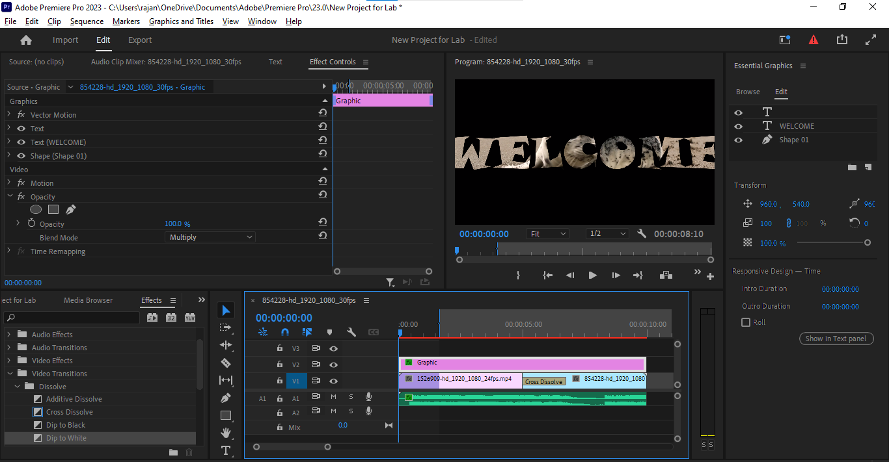

**6. Exporting the project**

* Prepare Sequence:
  + Ensure your sequence is fully rendered: Sequence > Render In to Out.
* Open Export Settings:
  + Go to File > Export > Media.
* Choose Export Settings:
* Format: Select format (e.g., H.264).
* Preset: Choose a preset (e.g., YouTube 1080p Full HD).
* Output Name: Set the name and save location.
* Customize Settings (if needed):
  + Adjust video and audio settings as necessary.
* Set Source Range:
  + Choose Entire Sequence or set In and Out points.
* Export or Queue:
  + Queue: Send to Adobe Media Encoder for batch processing.
  + Export: Export directly within Premiere Pro.
* Review Exported File:
  + Check the file in the save location to ensure quality.

**Conclusion**

In this lab, the fundamental functionalities of Adobe Premiere Pro were successfully explored, including importing and organizing media files, using the timeline and sequence for video editing, applying video effects, and performing basic audio editing and mixing. The process of exporting a completed project in various formats was also mastered. By gaining hands-on experience with these core aspects, better equipment for creating professional-quality video projects using Adobe Premiere Pro was achieved. This foundational knowledge will serve as a valuable asset for future multimedia endeavors.